Steps to upload program to ESP32-cam module via eclipse arduino IDE:

1. Take latest from esp32 git repo.

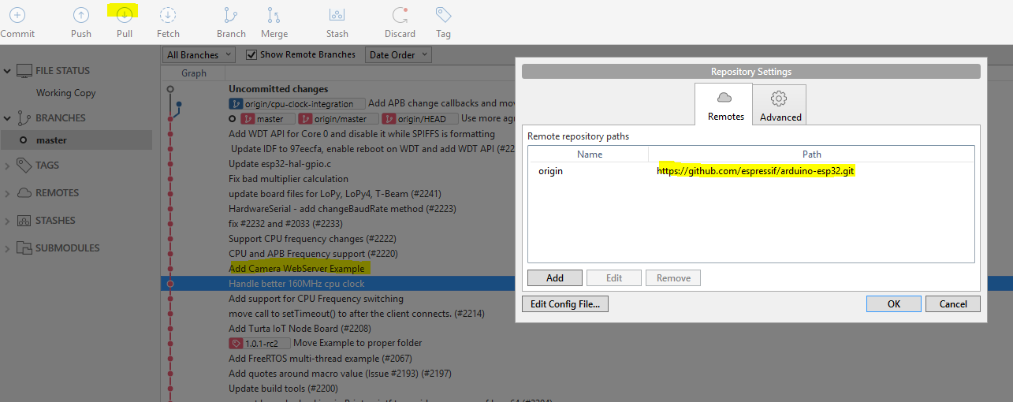

We can see that the camera sample is now ported for esp32 arduino ide.

1. Go to the folder where the library is checked out. E:\debojit\electronics project\2016\ide\eclipseArduino\**arduinoPlugin\packages\esp32\tools.**

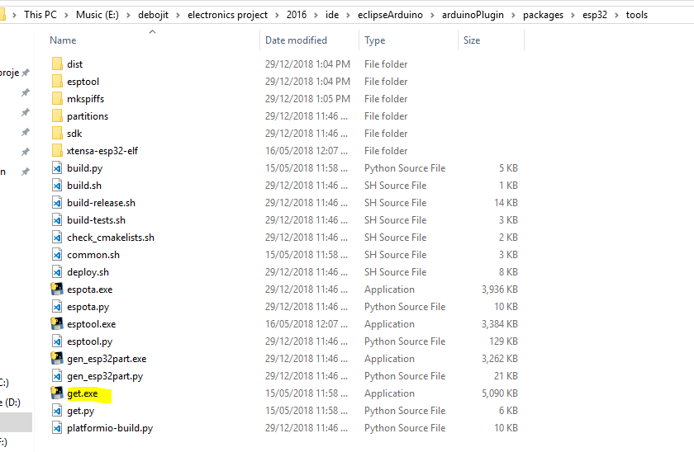

1. Double click to open the get.exe. It will get the latest tools and will create a folder esptool that contains the esptool.exe that actually builds the project.
2. Go to eclipse, create a blank Arduino project, and select esp32 board.

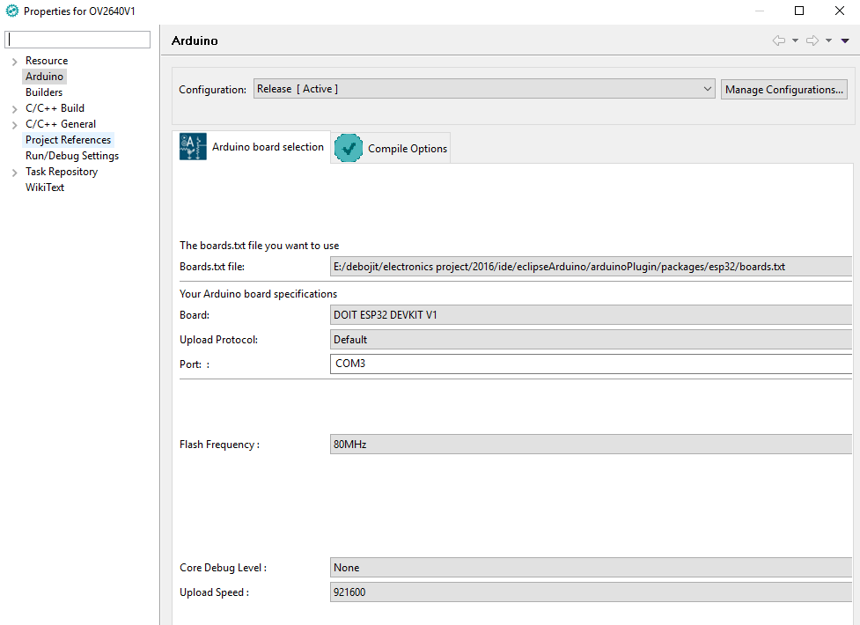

1. Paste the attached files into your code folder. Compile it.
2. Connect usb TX to RX0 and USB RX to TX0.

Power (3v3) and gnd to power up the board

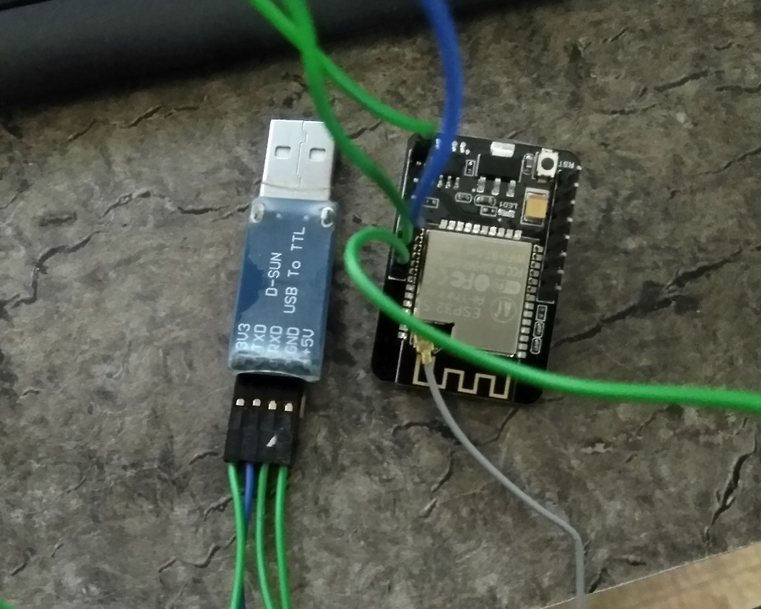

1. Before upload connect IO0 with gnd, and then press reset on the board.

**Note: While pressing reset make sure IO0 is connected to GND. You can use a jumper.**

On the serial console you will see the text: “Waiting for download”.

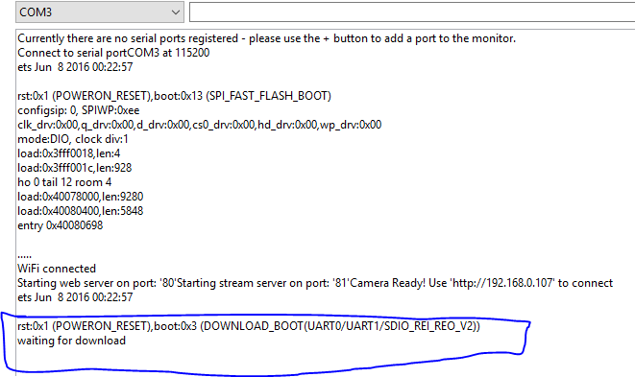

1. Now upload the program as usual. Reset it after upload. You will see that console will prompt the address. Open it on browser.
2. Click on the start stream button to start streaming.

